Project Design Phase

Solution Architecture
Date | 13 July 2026
Team ID | SWTID-2026-8803
Project Name | Book Doctor Management System
Maximum Marks | 4 Marks

Solution Architecture
Solution architecture bridges the gap between the healthcare appointment problem described earlier and the concrete MERN-stack technology solution. For the Book Doctor Management System, it:
- Defines the best-fit technology stack (React.js, Node.js, Express.js, MongoDB) to solve the appointment booking problem.
- Describes the structure, layers, and data flow of the application for all stakeholders (patients, doctors, administrators).
- Defines features, development phases, and solution requirements across the frontend, backend, and database.
- Provides the specification against which the solution is built, tested, and deployed.

Solution Architecture Diagram
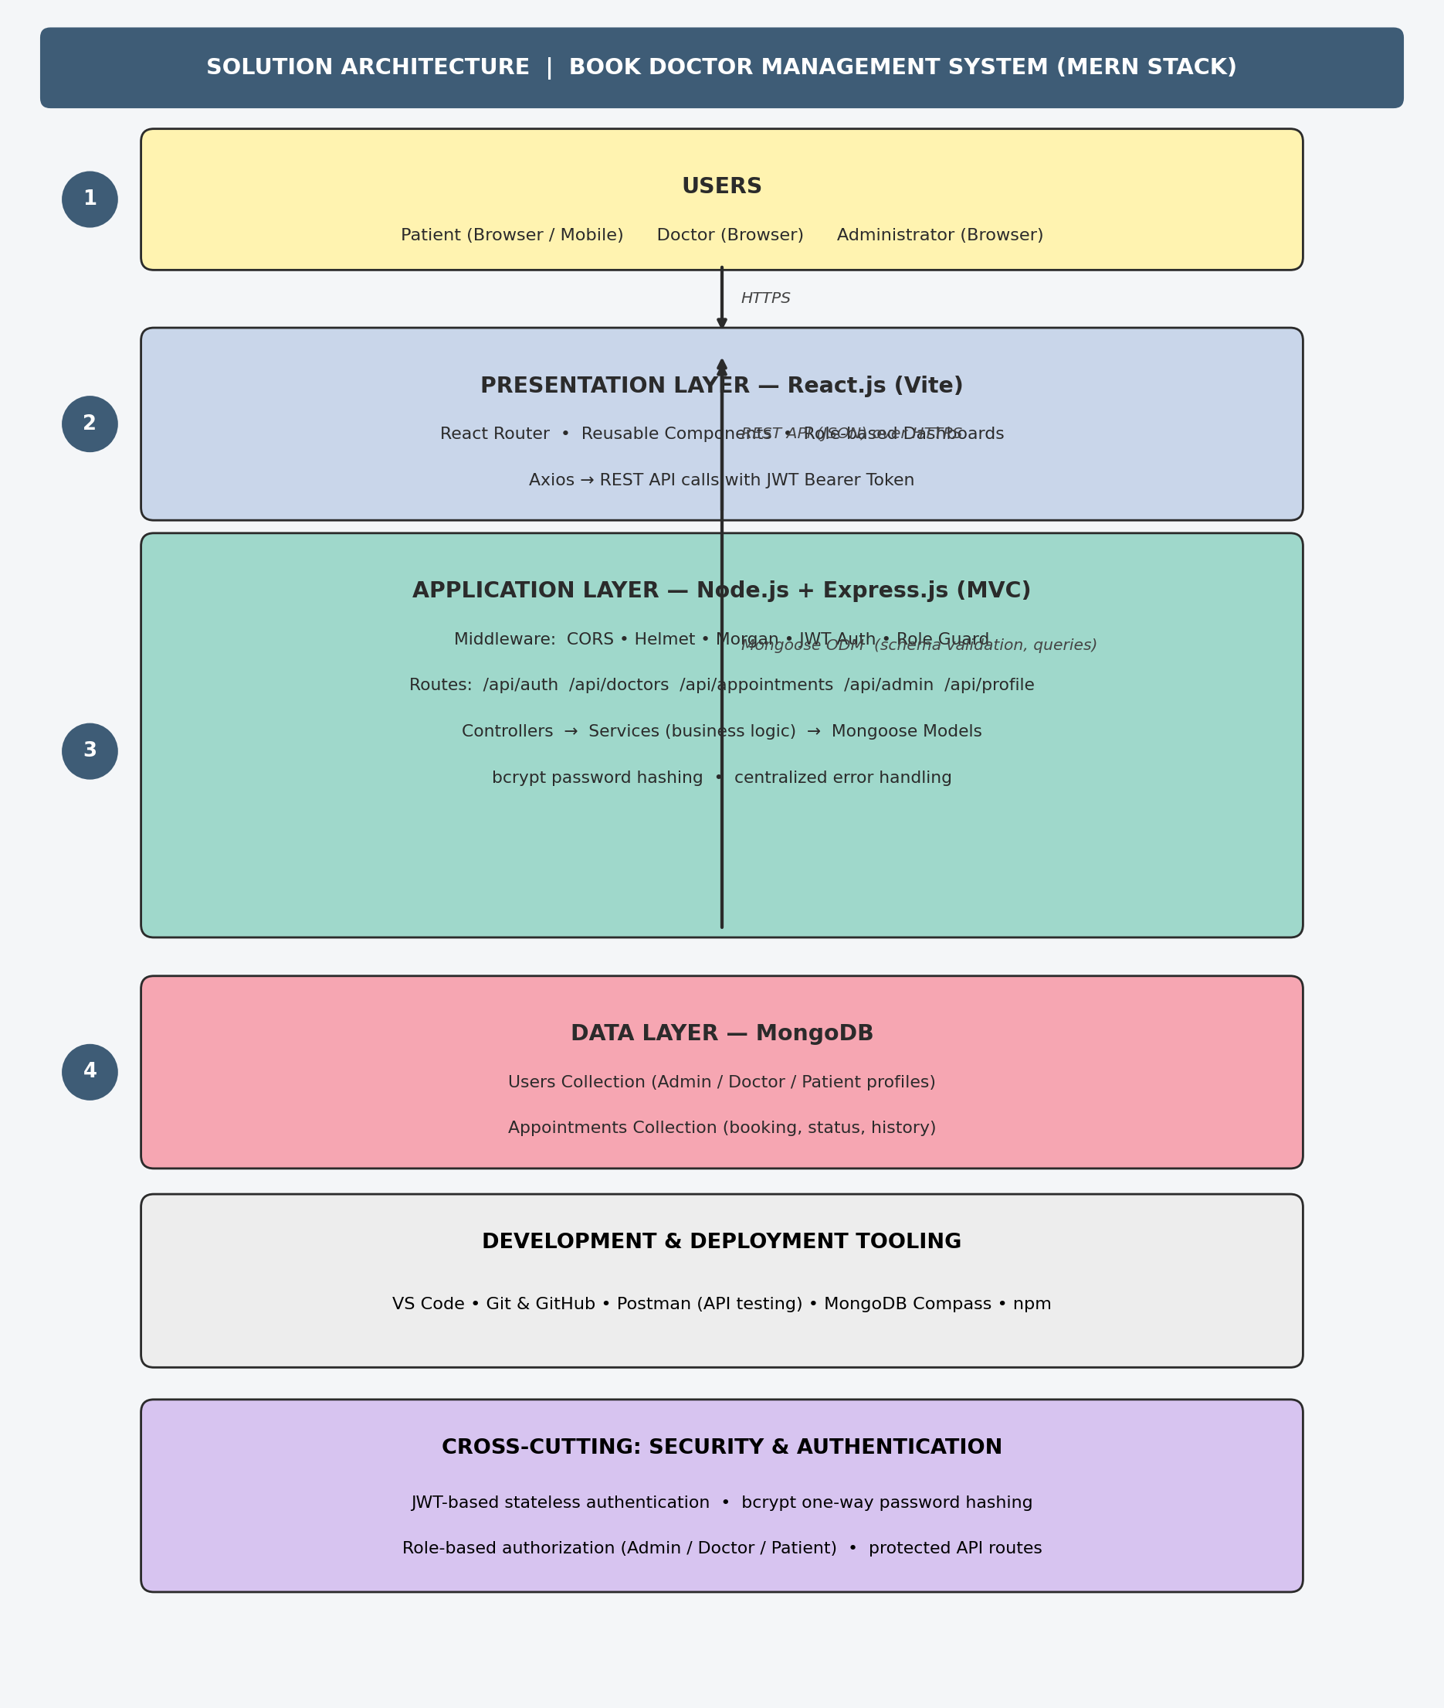
Figure 1: Solution architecture and data flow of the Book Doctor Management System

Architecture Summary
- Users (Patient, Doctor, Administrator) interact with the system through a browser or mobile device over HTTPS.
- The Presentation Layer is a React.js single-page application (built with Vite) using React Router for navigation and Axios to call REST APIs with a JWT bearer token attached to each request.
- The Application Layer is an Express.js server following the MVC pattern: middleware (CORS, Helmet, Morgan, JWT verification, role-based guards) validates and secures each request before it reaches Controllers, which delegate business logic to Services and persist data through Mongoose Models.
- The Data Layer is a MongoDB database with two primary collections — Users (Admin/Doctor/Patient profiles) and Appointments (booking, status, history) — accessed through Mongoose for schema validation and queries.
- Cross-cutting concerns — JWT authentication, bcrypt password hashing, and role-based authorization — are enforced across every layer to keep patient and appointment data secure.
- Development and deployment rely on VS Code, Git/GitHub for version control, Postman for API testing, and MongoDB Compass for database inspection.

